**Spring2018 Section 03 Team A**

**Beauty Blog**

**Project title: Beauty Plus**

**Team name: Team Trident**



**Team members:**

**Ashok Atkuri**

**Sai Praneetha Jaladanki**

**Rahul Reddy Lankala**

**Usability Test Plan:**

**Team roles and users**:

Table I: Team Roles and users

|  |  |
| --- | --- |
| Testing Location: | Student Union Meeting room |
| Test Users: | Students in the university |
| Facilitator: | Sai Praneetha Jaladanki |
| Human Computer: | Rahul Reddy Lankala |
| Log Keeper: | Ashok Atkuri |
| Video Recorder: | Ashok Atkuri, Rahul Reddy Lankala |

**Test methodologies and planning:**

Table II: Test methodologies

|  |  |
| --- | --- |
| Test method: | Allow each user to think loud and perform the task. |
| Domain knowledge: | User did have the knowledge of the interface. |
| Data collection: | Took the informed consent and recorded the time logs and the video of the activities performed. |
| User questionnaire: | Regarding the user’s satisfaction on using the website and asked for any further improvements |
| Time planning: | * Introduction: 2 minutes per user * Test tasks: 4 minutes per user * Questionnaire: 1 minutes per user * Total time for one user: 7minutes per user |

**Task:**

Task 1: Sign up for an account on the website

Task 2: Login as a user

Task 3: Search for products as per the category

Task 4: Search for reviews of products

Task 5: Review the products or the videos posted by others

Task 6: Post the tutorial makeup videos

Task 7: Make their comments

Task 8: Maintain User profiles by tracking their activities

Task 9: Admin should able to accept/reject any post

Task 10: Update the site with the new information

Task 11: Logout from the website

**Link for video:**

<https://drive.google.com/drive/u/0/folders/1KPJQ6CVsXHQxposNJa7htAYbez9Nhe_O>

**Quantifying the usability measures:**

Table III: Quantifying the usability measure

|  |  |  |
| --- | --- | --- |
| Usability measures | How we plan to quantify | Formula |
| Speed of performance | By considering the start time and end time of each task performed by user, we will measure the speed of performance. | (End Time-Start time) |
| Rate of errors by users | We will record the number of errors displayed while performing each task. | (Number of errors / Time taken to complete the task) |
| Subjective satisfaction | By asking a few questions to the user, we will know to what extent he is satisfied with the website. We would request the user to rate each task on a scale of 1 to 5 (1-poor, 2-fair, and 3-good, 4-very good and 5-excellent). | Use a Likert scale |
| Retention over time | It is how long a user can remember each task and perform the task. The performance can be better if the user’s knowledge of remembering the steps is high. |  |

**Usability logs:**

**User1:**

Table IV: User1 usability log

|  |  |  |  |  |  |  |
| --- | --- | --- | --- | --- | --- | --- |
| Task | Start time  (hh:mm:ss) | End time  (hh:mm:ss) | No of mouse clicks | No of key strokes | No of errors | Defects/comments |
| T1 | 11:32:01 | 11:33:01 | 4 | 68 | 0 | User successfully registered into website. |
| T2 | 11:33:03 | 11:33:15 | 1 | 0 | 0 | User successfully logged into website. |
| T3 | 11:33:19 | 11:33:25 | 1 | 0 | 0 | N/A |
| T4 | 11:33:28 | 11:33:38 | 1 | 0 | 0 | N/A |
| T5 | 11:33:41 | 11:33:55 | 1 | 0 | 0 | N/A |
| T6 | 11:33:57 | 11:34:25 | 2 | 25 | 2 | Confusion in finding the link to add tutorial |
| T7 | 11:34:28 | 11:34:45 | 1 | 0 | 0 | N/A |
| T8 | 11:34:48 | 11:36:04 | 2 | 22 | 1 | Confusion in reading and writing reviews |
| T9 | 11:36:07 | 11:36:30 | 1 | 0 | 0 | N/A |
| T10 | 11:36:34 | 11:36:45 | 1 | 0 | 0 | N/A |
| T11 | 11:36:49 | 11:37:06 | 2 | 0 | 0 | N/A |
| T12 | 11:37:09 | 11:37:15 | 1 | 0 | 0 | User successfully logged out of the website |

**User2:**

Table V: User2 usability log

|  |  |  |  |  |  |  |
| --- | --- | --- | --- | --- | --- | --- |
| Task | Start time  (hh:mm:ss) | End time  (hh:mm:ss) | No of mouse clicks | No of key strokes | No of errors | Defects/comments |
| T1 | 11:45:01 | 11:45:57 | 4 | 68 | 0 | N/A |
| T2 | 11:46:03 | 11:46:17 | 1 | 0 | 0 | N/A |
| T3 | 11:33:19 | 11:33:25 | 1 | 0 | 0 | N/A |
| T4 | 11:33:28 | 11:34:40 | 1 | 0 | 2 | Confusion in adding tutorial |
| T5 | 11:34:41 | 11:34:56 | 1 | 0 | 0 | N/A |
| T6 | 11:34:57 | 11:35:00 | 1 | 0 | 0 | Logged out as user |
| T7 | 11:35:05 | 11:35:17 | 1 | 0 | 0 | N/A |
| T8 | 11:35:20 | 11:36:06 | 5 | 45 | 0 | Logged in as Admin |
| T9 | 11:36:07 | 11:36:32 | 1 | 0 | 1 | Managing site content |
| T10 | 11:36:34 | 11:36:47 | 1 | 0 | 0 | N/A |
| T11 | 11:36:49 | 11:37:28 | 5 | 0 | 3 | Managing user posted content. Little confusion in finding user and their relevant info |
| T12 | 11:37:30 | 11:37:33 | 1 | 0 | 0 | Admin successfully logged out of the website |

**Usability Measures:**

**User1:**

Table VI: User1 usability measure

|  |  |  |  |  |  |  |  |  |  |  |  |  |
| --- | --- | --- | --- | --- | --- | --- | --- | --- | --- | --- | --- | --- |
| Usability measures | T1 | T2 | T3 | T4 | T5 | T6 | T7 | T8 | T9 | T10 | T11 | T12 |
| Speed of performance | 60 | 12 | 6 | 72 | 14 | 28 | 17 | 16 | 23 | 9 | 17 | 6 |
| Rate of errors | 0 | 0 | 0 | 0 | 0 | 0.07 | 0 | 0.06 | 0 | 0 | 0 | 0 |
| Subjective satisfaction | 4 | 5 | 4 | 5 | 5 | 5 | 5 | 5 | 4 | 5 | 5 | 5 |

**User2:**

Table VII: User1 usability measure

|  |  |  |  |  |  |  |  |  |  |  |  |  |
| --- | --- | --- | --- | --- | --- | --- | --- | --- | --- | --- | --- | --- |
| Usability measures | T1 | T2 | T3 | T4 | T5 | T6 | T7 | T8 | T9 | T10 | T11 | T12 |
| Speed of performance | 56 | 14 | 6 | 12 | 13 | 3 | 12 | 46 | 25 | 13 | 39 | 3 |
| Rate of errors | 0 | 0 | 0 | 0.16 | 0 | 0 | 0 | 0 | 0.04 | 0 | 0.07 | 0 |
| Subjective satisfaction | 5 | 4 | 4 | 4 | 3 | 4 | 4 | 4 | 3 | 5 | 5 | 5 |

**NOTE**: 1 – Strongly Agree 2- Agree 3- Neutral 4- Disagree 5- Strongly Disagree

**Survey using Likert’s Scale:**

**User1**:

Table VIII: User1 Survey using Likert’s Scale

|  |  |  |  |  |  |
| --- | --- | --- | --- | --- | --- |
| **Question** | **Strongly**  **Agree** | **Agree** | **Neutral** | **Disagree** | **Strongly Disagree** |
| Overall, I am satisfied with the website performance | **1** | **2** | **3** | **4** | **5** |
| It was fun to use the website | **1** | **2** | **3** | **4** | **5** |
| Whenever I needed support, I got it easily | **1** | **2** | **3** | **4** | **5** |
| The interface of this system is pleasant and user friendly | **1** | **2** | **3** | **4** | **5** |
| It is easy to find about a beauty product or routine and learn more about it | **1** | **2** | **3** | **4** | **5** |

**User2**:

Table IX: User 2 Survey using Likert’s Scale

|  |  |  |  |  |  |
| --- | --- | --- | --- | --- | --- |
| **Question** | **Strongly**  **Agree** | **Agree** | **Neutral** | **Disagree** | **Strongly Disagree** |
| Overall, I am satisfied with the website performance | **1** | **2** | **3** | **4** | **5** |
| It was fun to use the website | **1** | **2** | **3** | **4** | **5** |
| Whenever I needed support, I got it easily | **1** | **2** | **3** | **4** | **5** |
| The interface of this system is pleasant and user friendly | **1** | **2** | **3** | **4** | **5** |
| It is easy to find about a beauty product or routine and learn more about it | **1** | **2** | **3** | **4** | **5** |

**DEFECT LIST:**

Table X: User 1 and User2 Defect List

|  |  |  |  |
| --- | --- | --- | --- |
| S. No. | Defects | User1 | User2 |
| 1 | Link for profile to post tutorials as per the user | Yes | No |
| 2 | To be more clear regarding the admin functionalities as per the view. | No | Yes |
| 3 | In the page for tutorial, a preview was not supplied | No | No |

**Feedback User 1**

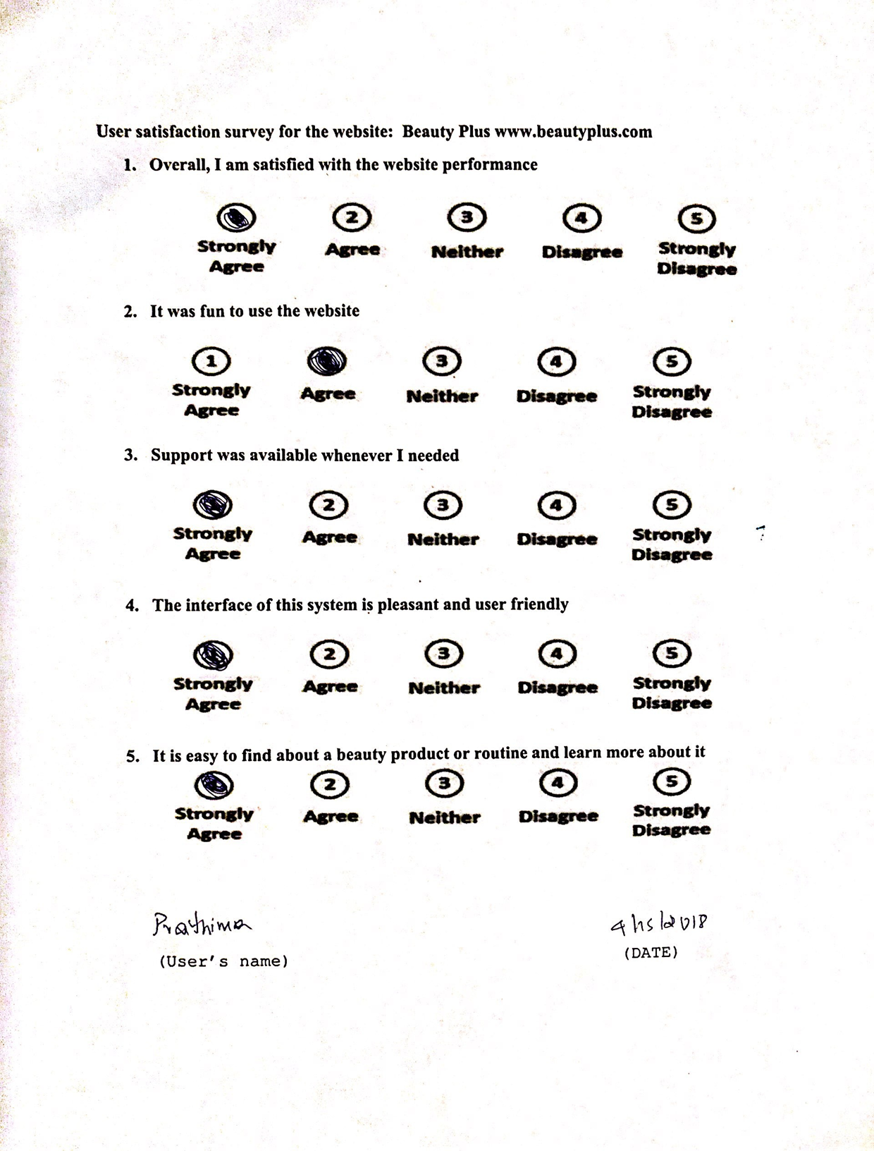

**Feedback User 2**

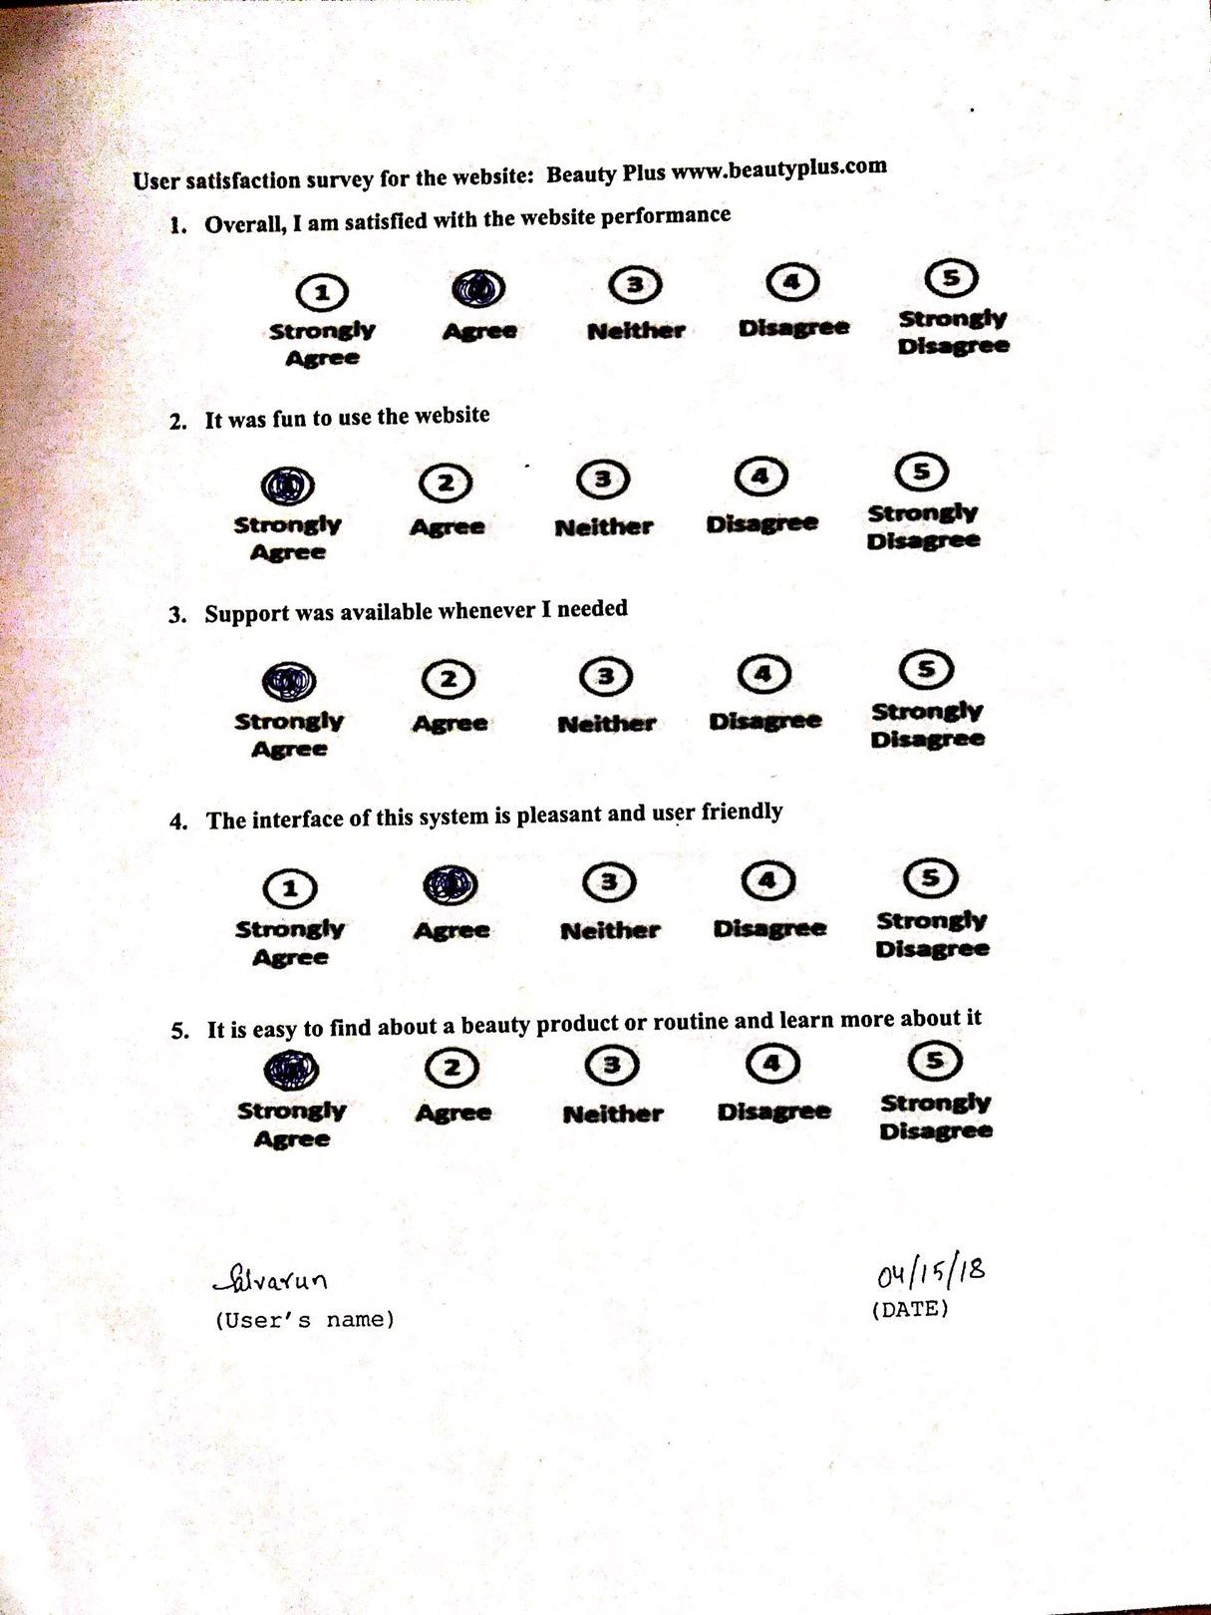

**Consent Form User 1**

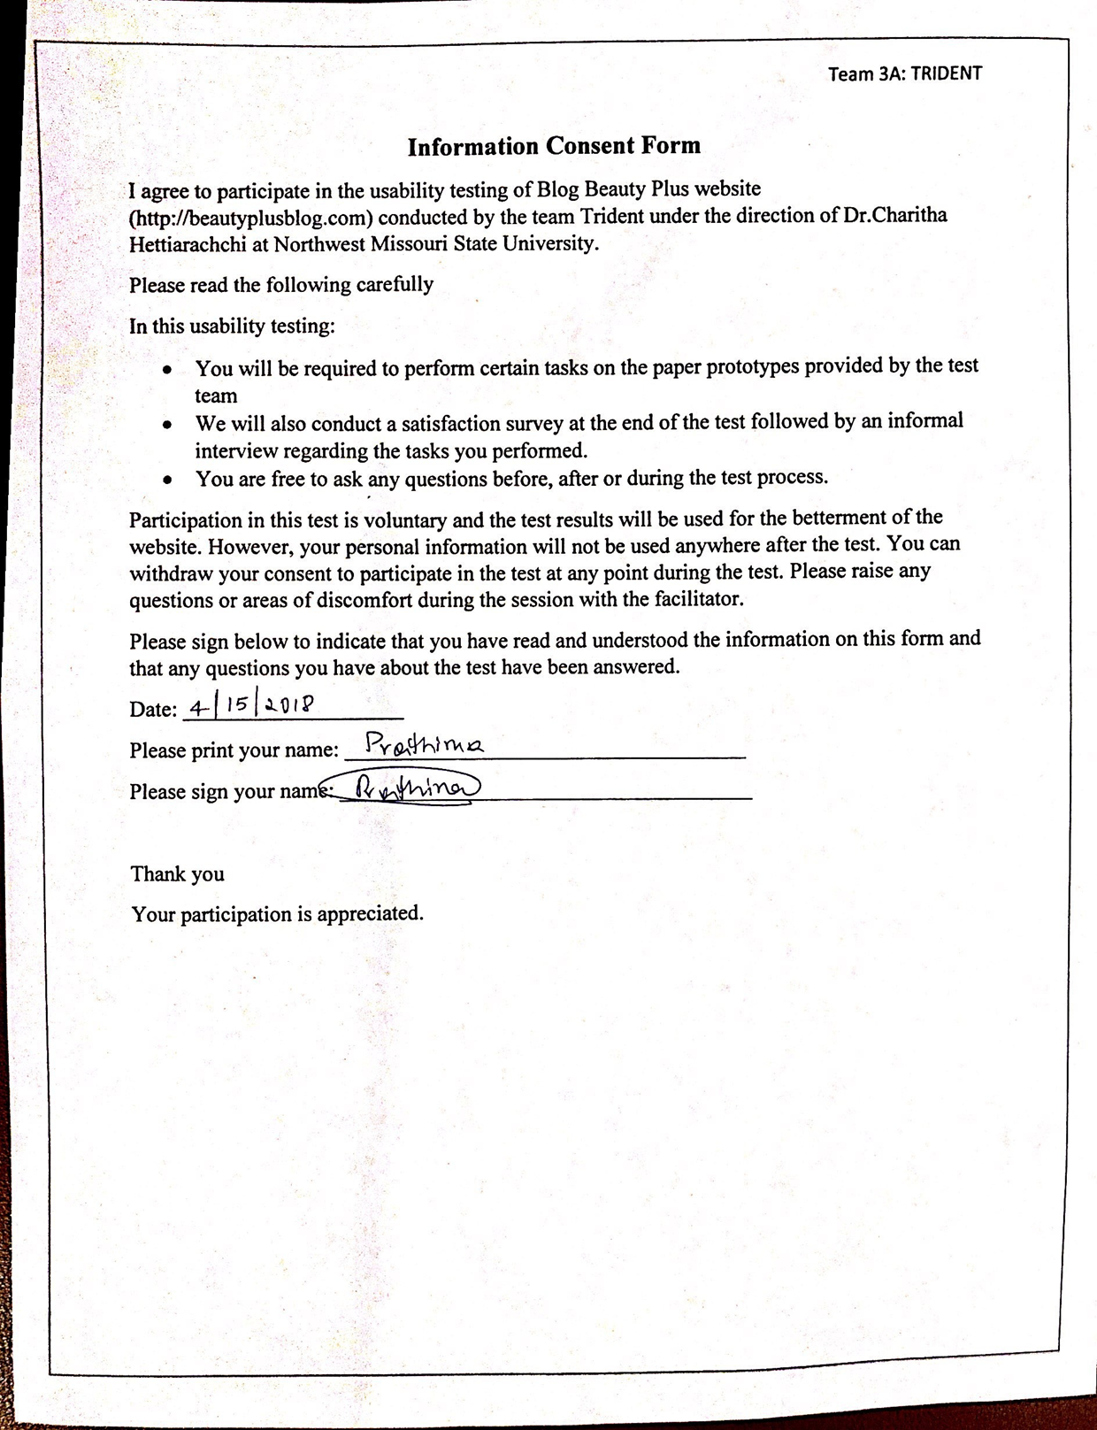

**Consent Form User 2**

